MIS 322 **Midterm** Page 1

VB.NET of 6

Name: Score: / 15 pts

**Project Description**

* This program will allow for users to enter items they wish to auction off. The user will enter all the information and see an estimated winning bid amount based on starting price and item condition.
* Work on your own. The TAs and instructor can offer help and hints at the cost of partial points.

**Auction Submission Form**

* Set up the form to resemble the one shown (see figure 1 below)
  + Quantity and Auction List are read-only textboxes and should not allow a user to tab onto them
  + Add a vertical scrollbar to the Auction List textbox
  + Set the form backcolor to a lighter shade of blue (AliceBlue is shown)
* Remember all StyleSheet settings

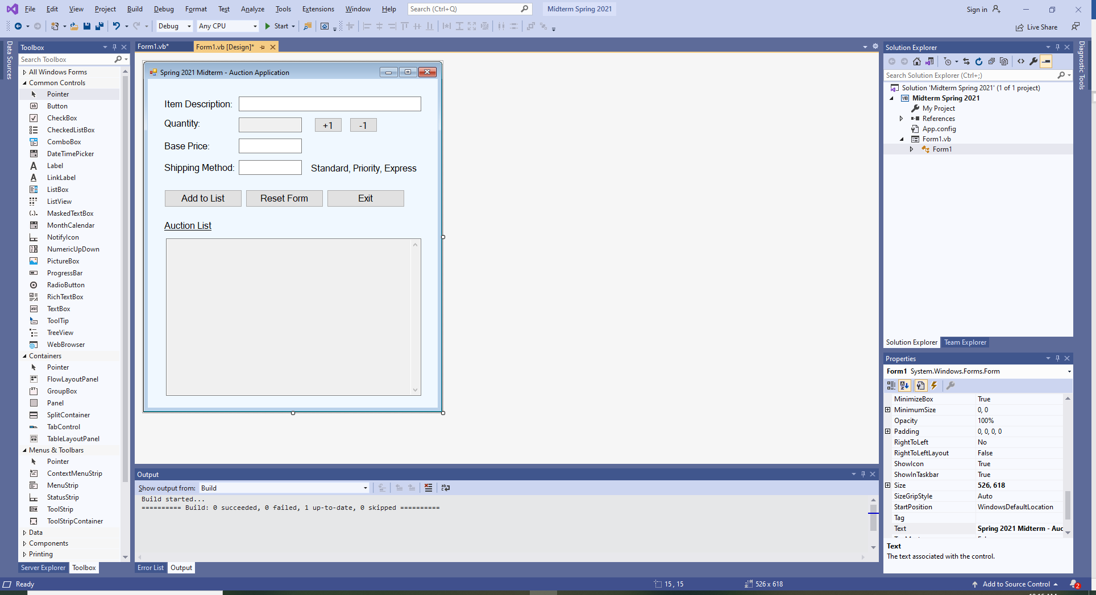

Figure 1: Auction Submission Design

**Auction Application Functionality**

* The Auction Application will perform the following tasks:

**Quantity Buttons**

* + The +1 and -1 quantity buttons will either increase or decrease the quantity by 1
    - Initially set quantity to 1 on form load
    - The minimum quantity is 1
    - The maximum quantity is 12
    - Error trap to enforce the acceptable range, informing the user of any attempt to set the quantity out of range
    - Use a class level variable to track quantity

**Add to List Button**

* + Verify there is an entry for all textboxes
    - Item Description cannot be blank
    - Base Price must be a positive, non-zero number
      * Decimal points are acceptable
      * Commas and currency symbols are not
    - Shipping Method is limited to Standard, Priority or Express
      * Field is not case sensitive (i.e. Standard, STANDARD, StAnDaRd are all acceptable)
  + Prompt user for condition of item or items in the auction lot and calculate adjusted price
    - Use an inputbox to get user input (See figure 3)
    - Check input after OK button is clicked
      * Only acceptable conditions are New, Used or Salvage
      * Field is not case sensitive (i.e. New, NEW, NeW are all acceptable)
      * The default entry for the inputbox will initially be set to “NEW” in form load event
        + A variable will store the last entry and will then become the default for the next inputbox
        + If a user enters “Used” for an item, the next time a condition is requested from the user, “Used” will appear as the default entry

**Adjusted Price Calculation**

* The application will adjust the item price for the item(s) based on the condition
  + New items will have an adjustment factor of **1** (no change to base price)
  + Used items will have an adjustment factor of **0.75** times the base price
  + Salvage items will have an adjustment factor of **0.25** times the base price

**Shipping Method Cost Calculation**

* The application will add on the shipping cost associated with shipping method
  + Costs will be stored in class level constant variables

|  |  |
| --- | --- |
| Method | Cost |
| Standard | **5.95** |
| Priority | **8.95** |
| Express | **12.95** |

**Total Cost Calculation**

* The application calculate a total cost based on adjusted price, quantity and shipping method
  + Total cost = adjusted price x quantity + shipping cost
  + See figure 4 for check figures (Three $500 used items with priority shipping)

**Summary of Auction Lot**

* + Construct a summary structured as seen in Figure 4 and display it in the Auction List textbox
    - The summary will include:
      * Lot Number
      * Item Description
      * Base Price
      * Adjusted Price
      * Quantity
      * Shipping Method
      * Shipping Cost
      * Total Cost
    - Identify the lot number, starting with 1 (See figure 5)
      * Subsequent lots will continue with the next number (2, 3, 4, etc.)
    - Format any price or cost as currency to 2 places
    - Separate lots by using a series of dashes, equal signs or asterisks (See figure 5)
  + Notify the user of any errors of omission or invalid entries
    - Error messages should be specific to the type of error and location of error
    - Exit sub upon encountering any errors

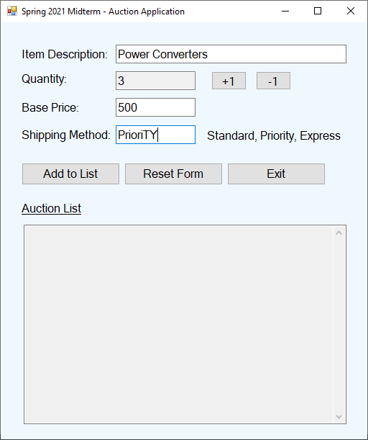

Figure 2: Auction Application at Runtime

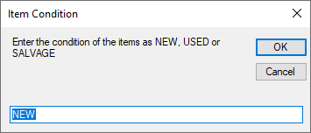

Figure 3: Inputbox to enter Item Condition

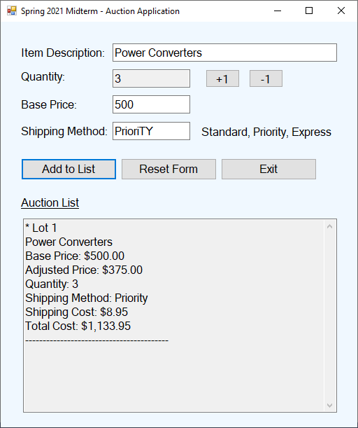

Figure 4: Auction Lot Display for Used item with Priority Shipping

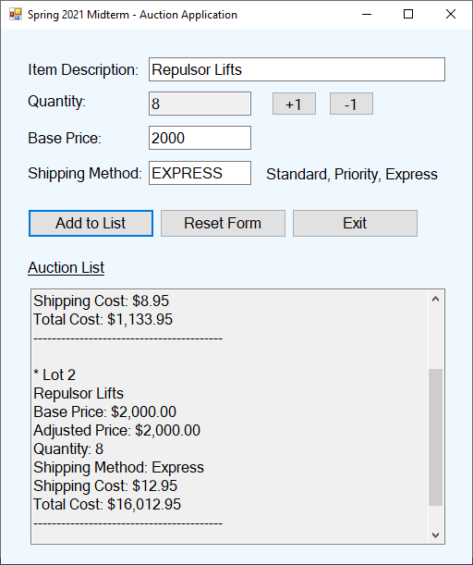

Figure 5: Second Auction Lot Added With Items in New Condition

**Reset Form Button**

* Reset the form’s objects to the initial condition
  + Clear all entries from all textboxes
  + Set quantity variable to one
  + Set quantity textbox to one
  + Reset auction lot back to 1
  + Set focus to Item Description textbox

**Exit Button**

* Exit the program

Zip up your project and upload to Canvas when completed